# Database Basics MS SQL Exam – 16 Apr 2019

Exam problems for the [“Database Basics” course @ SoftUni](https://softuni.bg/courses/databases-basics-ms-sql-server).

Submit your solutions in the SoftUni Judge system at <https://judge.softuni.bg/>

# Airport

# Section 1. DDL (30 pts)

You are given an E/R Diagram of the Airport:

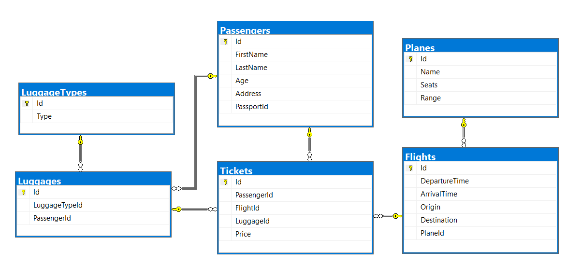

Crеate a database called Airport. You need to create **6 tables**:

* Planes – contains information about the **planes**.
* Flights – contains information about the **flights**.
  + Each flight has a plane.
* Passеngers – contains information about the **passengers**
* LuggageTypes – contains information about the **type of luggages**.
* Luggages – contains information about the **luggages**.
  + Each luggage has a luggage type.
* Tickets – contains information about the tickets.
  + Each ticket has a passenger.
  + Each ticket has a flight.
  + Each ticket has a luggage.

**Planes**

|  |  |  |
| --- | --- | --- |
| **Column Name** | **Data Type** | **Constraints** |
| Id | **Integer** from **0** to **2,147,483,647** | Unique table **identificator**, **Identity** |
| Name | **String** up to 30 symbols | **NULL** is **not** allowed |
| Seats | **Integer** from **0** to **2,147,483,647** | **NULL** is **not** allowed |
| Range | **Integer** from **0** to **2,147,483,647** | **NULL** is **not** allowed |

**Flights**

|  |  |  |
| --- | --- | --- |
| **Column Name** | **Data Type** | **Constraints** |
| Id | **Integer** from **0** to **2,147,483,647** | Unique table **identificator**, **Identity** |
| DepartureTime | **Datetime** | None |
| ArrivalTime | **Datetime** | None |
| Origin | **String** up to 50 symbols | **NULL** is **not** allowed |
| Destination | **String** up to 50 symbols | **NULL** is **not** allowed |
| PlaneId | **Integer** from **0** to **2,147,483,647** | **NULL** is **not** allowed, Relationship with table Planes |

**Passengers**

|  |  |  |
| --- | --- | --- |
| **Column Name** | **Data Type** | **Constraints** |
| Id | **Integer** from **0** to **2,147,483,647** | Unique table **identificator**, **Identity** |
| FirstName | **String** up to 30 symbols | **NULL** is **not** allowed |
| LastName | **String** up to 30 symbols | **NULL** is **not** allowed |
| Age | **Integer** from **0** to **2,147,483,647** | **NULL** is **not** allowed |
| Address | **String** up to 30 symbols | **NULL** is **not** allowed |
| PassportId | **String** with **exactly 11** symbols | **NULL** is **not** allowed |

**LuggageTypes**

|  |  |  |
| --- | --- | --- |
| **Column Name** | **Data Type** | **Constraints** |
| Id | **Integer** from **0** to **2,147,483,647** | Unique table **identificator**, **Identity** |
| Type | **String** up to 30 symbols | **NULL** is **not** allowed |

**Luggages**

|  |  |  |
| --- | --- | --- |
| **Column Name** | **Data Type** | **Constraints** |
| Id | **Integer** from **0** to **2,147,483,647** | Unique table **identificator**, **Identity** |
| LuggageTypeId | **Integer** from **0** to **2,147,483,647** | **NULL** is **not** allowed, Relationship with table **LuggageTypes** |
| PassengerId | **Integer** from **0** to **2,147,483,647** | **NULL** is **not** allowed, Relationship with table **Passengers** |

**Tickets**

|  |  |  |
| --- | --- | --- |
| **Column Name** | **Data Type** | **Constraints** |
| Id | **Integer** from **0** to **2,147,483,647** | Unique table **identificator**, **Identity** |
| PassengerId | **Integer** from **0** to **2,147,483,647** | **NULL** is **not** allowed, Relationship with table **Passengers** |
| FlightId | **Integer** from **0** to **2,147,483,647** | **NULL** is **not** allowed, Relationship with table **Flights** |
| LuggageId | **Integer** from **0** to **2,147,483,647** | **NULL** is **not** allowed, Relationship with table **Luggages** |
| Price | **Decimal** number with **two-digit** precision | **NULL** is **not** allowed |

## Database Design

Submit all of yours **create** **statements** to Judge (only creation of tables).

# Section 2. DML (10 pts)

**Before you start, you must import “**DataSet-Airport.sql**”. If you have created the structure correctly, the data should be successfully inserted without any errors.**

In this section, you have to do some data manipulations:

## Insert

**Insert** some sample data into the database. Write a query to add the following records into the corresponding tables. **All Ids should be auto-generated**.

**Planes**

|  |  |  |
| --- | --- | --- |
| Name | Seats | Range |
| Airbus 336 | 112 | 5132 |
| Airbus 330 | 432 | 5325 |
| Boeing 369 | 231 | 2355 |
| Stelt 297 | 254 | 2143 |
| Boeing 338 | 165 | 5111 |
| Airbus 558 | 387 | 1342 |
| Boeing 128 | 345 | 5541 |

**Luggage Types**

|  |
| --- |
| Type |
| Crossbody Bag |
| School Backpack |
| Shoulder Bag |

## Update

Make all flights to "**Carlsbad**" 13% more expensive.

## Delete

Delete all flights to "**Ayn Halagim**".

# Section 3. Querying (40 pts)

**You need to start with a fresh dataset, so recreate your DB and import the sample data again (**DataSet-Bitbucket.sql**).**

## The "Tr" Planes

Select all of the **planes,** which name contains "**tr**". Order them by **id** (ascending), **name** (ascending), **seats** (ascending) and **range** (ascending).

### Examples

|  |  |  |  |
| --- | --- | --- | --- |
| **Id** | **Name** | **Seats** | **Range** |
| 31 | Trunyx | 195 | 2653 |
| 86 | Yakitri | 321 | 1360 |
| 87 | Trilith | 223 | 4375 |
| … | … | … | … |

## Flight Profits

Select the total profit for each flight from database. Order them by **total price** (descending), **flight id** (ascending).

### Examples

|  |  |
| --- | --- |
| **FlightId** | **Price** |
| 58 | 828.43 |
| 43 | 819.84 |
| … | … |

## Passenger Trips

Select the **full name** of the passengers with their trips (**origin** - **destination**). Order them by **full name** (ascending), **origin** (ascending) and **destination** (ascending).

### Examples

|  |  |  |
| --- | --- | --- |
| **Full Name** | **Origin** | **Destination** |
| Adina Uvedale | Lawa-an | Hulei |
| Adolphe Juste | Boto | Pantubig |
| Adolphe Juste | Codrington | Kasiyan |
| … | … | .. |

## Non Adventures People

Select all people who don't have tickets. Select their **first name**, **last name** and **age** .Order them by **age** (descending), **first name** (ascending) and **last name** (ascending).

### Examples

|  |  |  |
| --- | --- | --- |
| **First Name** | **Last Name** | **Age** |
| Felipa | Wabe | 89 |
| Darius | Ellissen | 87 |
| Eleen | Ummfrey | 86 |
| … | … | .. |

## Full Info

Select all passengers who have **trips**. Select their **full name** (first name – last name), **plane name**, trip (in format {**origin**} - {**destination**}) and luggage type. Order the results by **full name** (ascending), **name** (ascending), **origin** (ascending), **destination** (ascending) and **luggage type** (ascending).

### Examples

|  |  |  |  |
| --- | --- | --- | --- |
| **Full Name** | **Plane Name** | **Trip** | **Luggage Type** |
| Adina Uvedale | Feedspan | Lawa-an - Hulei | Wheeled Business Case |
| Adolphe Juste | Babbleopia | Usagara - Ikhtiman | Upright Luggage |
| Adolphe Juste | Feednation | Le Mans - Grazhdanka | Duffel Bag |
| … | … | … | … |

## PSP

Select **all planes** with their **name**, **seats count** and **passengers count**. Order the results by **passengers count** (descending), **plane name** (ascending) and **seats** (ascending)

### Examples

|  |  |  |
| --- | --- | --- |
| **Name** | **Seats** | **Passengers Count** |
| Jabberbean | 56 | 6 |
| Youbridge | 159 | 5 |
| Yoveo | 247 | 5 |
| … | … | … |

# Section 4. Programmability (20 pts)

## Vacation

Create a **user defined function**, named **udf_CalculateTickets(@origin, @destination, @peopleCount)** that receives an origin (town name), destination (town name) and people count.

The function must return the total price in format "**Total price {price}**"

* If people count is less or equal to zero return – "**Invalid people count!**"
* If flight is invalid return – "**Invalid flight!**"

### Example:

|  |
| --- |
| **Query** |
| **SELECT** **dbo.udf_CalculateTickets**(**'Kolyshley'**,**'Rancabolang'**, **33**) |
| **Output** |
| **Total price 2419.89** |

|  |
| --- |
| **Query** |
| **SELECT** **dbo.udf_CalculateTickets**(**'Kolyshley'**,**'Rancabolang'**, **-1**) |
| **Output** |
| **Invalid people count!** |

|  |
| --- |
| **Query** |
| **SELECT** **dbo.udf_CalculateTickets**(**'Invalid'**,**'Rancabolang'**, **33**) |
| **Output** |
| **Invalid flight!** |

## Wrong Data

Create a **user defined stored procedure**, named **usp_CancelFlights**  
The procedure must cancel all flights on which the arrival time is before the departure time. Cancel means you need to leave the departure and arrival time empty.

### Example:

|  |
| --- |
| **Query** |
| **EXEC** **usp_CancelFlights** |
| **Output** |
| (49 rows affected) |